# Analysis – use cases summary

This is mostly a work document for the post-elicitation stage done with all analysts after the initial interviews and document reviews. Do this first. It’s a summary of the use cases in bullets or numbers serving like a table of contents. This is an optional part of a project document but when there are many use cases, it is very helpful.

## Actors

First step in analysis is to brainstorm and validate these roles and/or systems.

* Customer
* Operator
* Security

## Use case names

Second step in analysis is to brainstorm and validate scope at the goal level.

### System use cases

Only those use cases which start after the software is running and an actor directly interacts with the system.

* Withdraw cash
* Query balance
* Deposit funds
* Transfer funds

### Business use cases

Any use case that does not completely exist as an interaction between software and the actor.

* Restock cash
* Restock paper
* Empty card bin
* Remove deposits

|  |  |  |  |  |
| --- | --- | --- | --- | --- |
| Use case name | Business /  Market  usage %  (3=100-67  2= 66-34, 1=0-33%) | Business / pricing value ( 3=exec/high,  2=mgmt./med.  1=supervisory/low) | Result = Market * Value | Total  count of  top 3 -  group |
| Withdraw cash |  |  |  | 6 |
| Query balance |  |  |  | 2 |
| Deposit funds |  |  |  | 5 |
| Transfer funds |  |  |  | 1 |
| Restock cash |  |  |  | 2 |
| Restock paper |  |  |  | 0 |
| Empty card bin |  |  |  | 0 |
| Remove deposits |  |  |  | 2 |

### Use case diagram

Here would be a good place to put a diagram(s) showing the relationships of all the use cases. A good online tool is https://yuml.me/diagram/usecase/draw

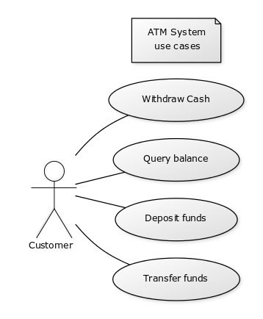# https://yuml.me/diagram/nofunky/usecase/draw

(note: ATM System use cases)

[Customer]- Withdraw Cash

[Customer]- Query balance

[Customer]- Deposit funds

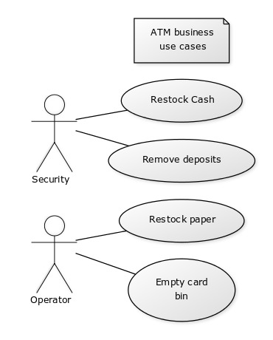[Customer]- Transfer funds

# https://yuml.me/diagram/nofunky/usecase/draw

(note: ATM business use cases)

[Security] - Restock Cash

[Security] - Remove deposits

[Operator] - Restock paper

[Operator] - Empty card bin

## Grouped use cases

Use cases can be structured to roll up to a group name but are useful when complexity is high. Place bigger use cases that don’t all have the same flow of events here but have a common theme.

Grouped use cases are either system or business use cases and can be groups of goal level use cases or groups of partial use cases. Also common in this section are the Manage <Entity> type of use case which expands into the CRUD use cases. e.g. Manage Account = Create Account, Read Account (Display details of account), Update Account, Delete Account.

* Perform maintenance

## Partial goal names found

Use cases can be structured to drill down to a sequence of tasks not ending in a goal with value or repeatable. That sequence may be assigned a name to help out understanding e.g. Log In or Search for Product. These are helpful to identify reusable parts and cut down the amount of repeated text in a set of use cases, but not necessary.

* Cancel transaction